**Question 1 -**

https://www.hackerrank.com/contests/w33/challenges/twin-arrays/problem

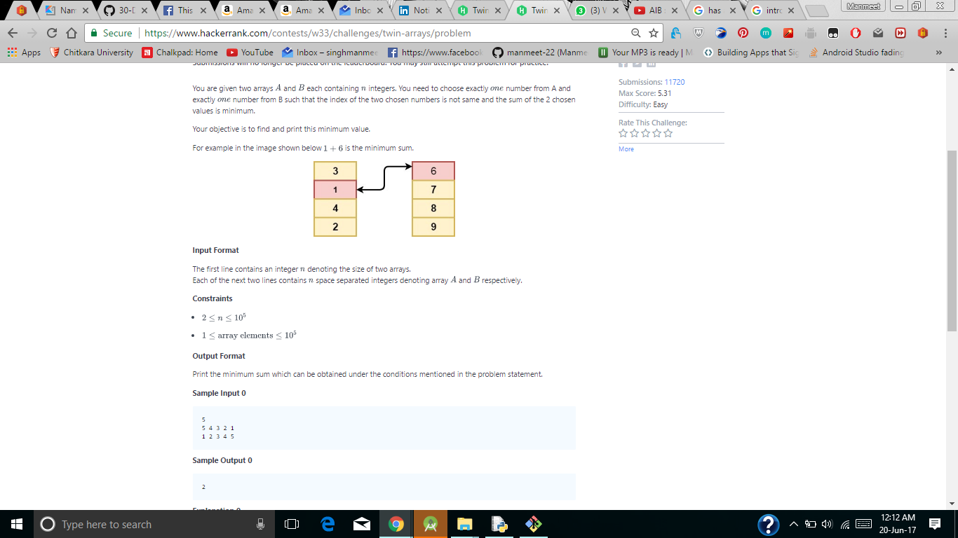

**Question 1 -**

**Question 1 -**

**Question 1 -**

**Question 1 -**

**Question 1 -**